**Many-to-one Relationship in Hibernate**

* Many– to – One relationship occurs when Many records in “Primary Table” corresponds to exactly one record in the “Relationship Table”
* We can achieve Many – to – One relationship between tables by having common column in “Primary Table” & “Relationship Table” having that column as Normal Column in “Primary Table” & Primary Key in “Relationship Table” table as shown below

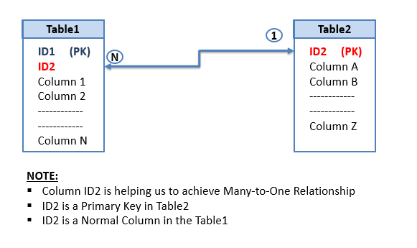

* In Hibernate we achieve Many – to – One relationship with the help of **<Many-to-one>**tag in the mapping file of the Java Bean which corresponds to the Primary Table.

<many-to-one

name=*"propertyNM"*

column=*"relationshipColumn"*

class=*"pkgNM.RelationshipBeanName"*

fetch=*"select"*/>

* Fetch attribute instruct the Hibernate how to fetch the Related object records which fetching the Primary Object. It helps Hibernate to generate Select SQL queries based on the value it has.

1. fetch=*"select"* will load all the Related Objects whenever we try to operate with related objects
2. fetch=*"join"* will always load all the Related Objects while reading the Primary Object

* The @ManyToOne annotation is used to create the many-to-one relationship between two entities.
* The cascade option is used to cascade the required operations to the associated entity. If the cascade option is set to CascadeType.ALL then all the operations will be cascaded.